EXPERIMENT 10
Simulation and Performance Evaluation of NOMA and Successive Interference Cancellation
Aim
To model a two-user power-domain NOMA system in MATLAB, implement successive interference cancellation (SIC), and compare its bit error rate (BER) with a simplified OFDMA system.
Procedure
- Open MATLAB and create Exp10_NOMA_SIC.m.
- Set the number of bits and SNR range from 0 to 20 dB.
- Assign power coefficients \(\alpha_1=0.75\) and \(\alpha_2=1-\alpha_1\).
- Generate random binary data for both users.
- Convert the binary data into BPSK symbols.
- Combine both users’ symbols using their power coefficients to generate the NOMA signal.
- Add AWGN to the transmitted signal.
- Detect the higher-power User 1 signal.
- Reconstruct and subtract the detected User 1 contribution to perform SIC.
- Detect User 2 from the residual signal and calculate BER for both users.
- Generate a simplified OFDMA reference and compare the BER curves.
- Repeat the simulation with different power-allocation coefficients.
MATLAB PROGRAM
clc;
clear;
close all;
rng(10);

Nbits = 50000;
SNRdB = 0:2:20;

alpha1 = 0.75;
alpha2 = 1-alpha1;

berU1 = zeros(size(SNRdB));
berU2 = zeros(size(SNRdB));
berOFDMA = zeros(size(SNRdB));

for s = 1:length(SNRdB)

b1 = randi([0 1],Nbits,1);
b2 = randi([0 1],Nbits,1);

% BPSK modulation
x1 = 2*b1-1;
x2 = 2*b2-1;

snr = 10^(SNRdB(s)/10);
noise = randn(Nbits,1)/sqrt(2*snr);

% NOMA superposition
y = sqrt(alpha1)*x1 + sqrt(alpha2)*x2 + noise;

% Detect high-power User 1
b1hat = y > 0;
x1hat = 2*b1hat-1;
berU1(s) = mean(b1hat ~= b1);

% Successive interference cancellation
y2 = y - sqrt(alpha1)*x1hat;

% Detect User 2 after SIC
b2hat = y2 > 0;
berU2(s) = mean(b2hat ~= b2);

% Simplified OFDMA reference with separate resources
yO = x1 + randn(Nbits,1)/sqrt(snr);
bO = yO > 0;
berOFDMA(s) = mean(bO ~= b1);
end

% Display BER values
disp('SNR(dB) User1 BER User2 BER OFDMA BER');
disp([SNRdB(:) berU1(:) berU2(:) berOFDMA(:)]);

% Plot BER curves
figure;
semilogy(SNRdB,max(berU1,1/Nbits),'ro-','LineWidth',1.2);
hold on;
semilogy(SNRdB,max(berU2,1/Nbits),'bs-','LineWidth',1.2);
semilogy(SNRdB,max(berOFDMA,1/Nbits),'k--','LineWidth',1.2);
grid on;
xlabel('SNR (dB)');
ylabel('Bit Error Rate');
title('NOMA with SIC and OFDMA BER Comparison');
legend('NOMA User 1','NOMA User 2 after SIC','OFDMA');
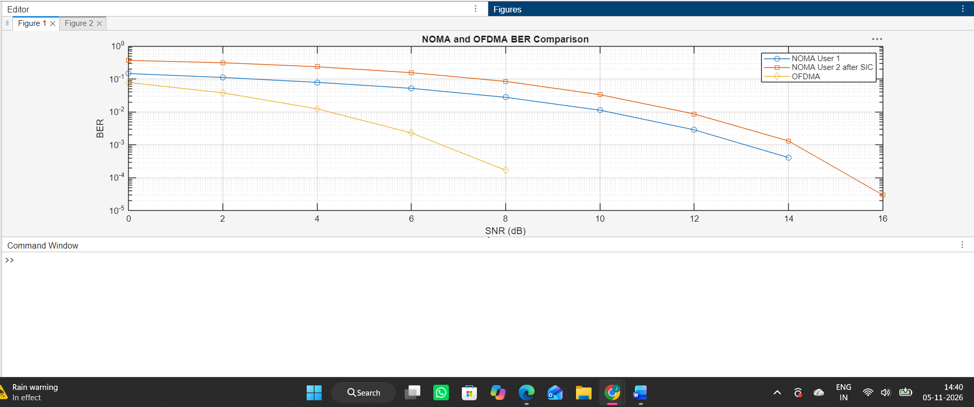

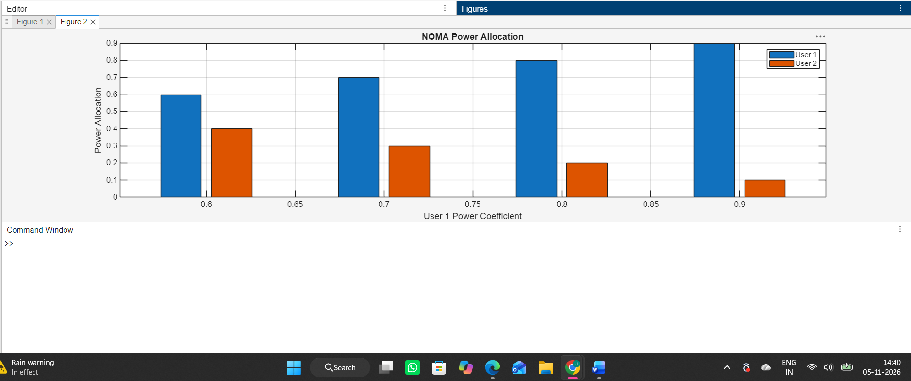

Result
The two-user NOMA system was simulated using power-domain superposition and SIC. BER values were calculated over the selected SNR range and plotted against a simplified OFDMA reference. Record the BER values and observations from your MATLAB output.

